Digital Design Diploma

# **Assignment 1 [Extra]**

# **Combinational Circuit Design**

|  |  |
| --- | --- |
| **Name** | كريم حسن عاطف علي |
| **Group** | G2 |

**Submitted to: Eng. Kareem Waseem**

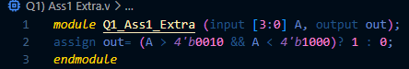**1)**

Figure 1: Q1 Code



Figure2: Q1 Wave

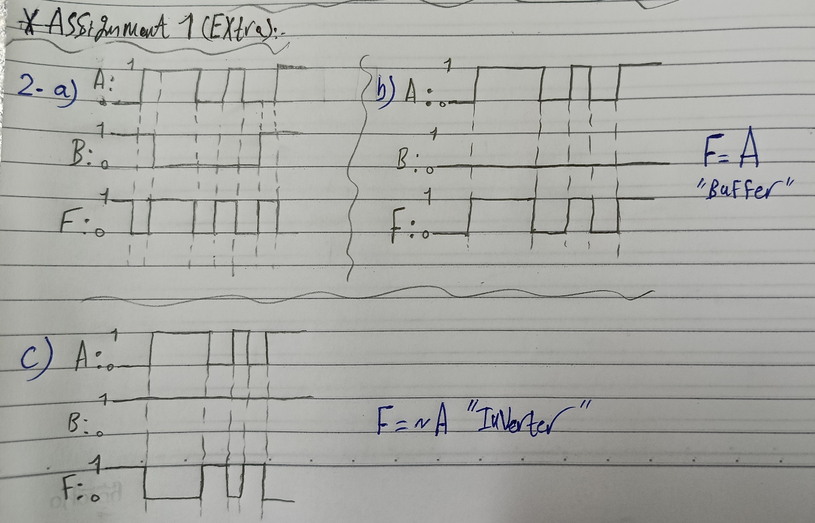**2)**

Figure 3: Q2 Wave

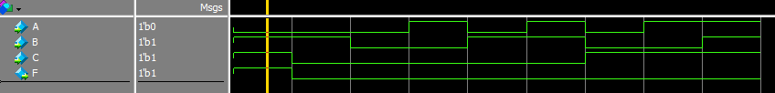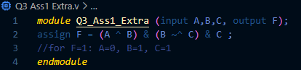**3)**

Figure 4: Q3 Code

Figure 5: Q3 Wave

**4)**

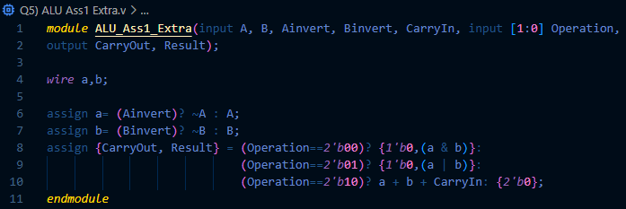**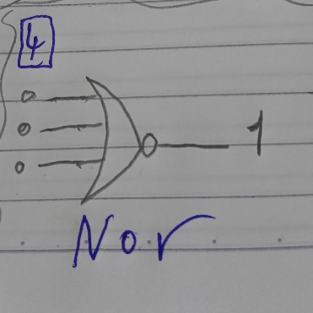5)**

Figure 6: Q4

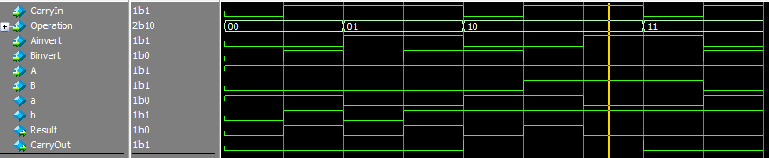

Figure 7: Q5 Code

Figure 8: Q5 Wave